Green Architectural Engineering: Wellness Center Report

Jamey Hogarth, Rachel Lacek, & Kelly Bresnowitz

Department of Physics and Engineering
Elizabethtown College, Elizabethtown, PA
Email: hogarthj@etown.edu, lacekr@etown.edu, & bresnowitzk@etown.edu

Abstract

This project is to design a wellness center to propose for possible construction at Elizabethtown College. The proposed designs for the wellness center should also take LEED Certification aspects into consideration when designing the buildings. Other things to consider include location and consideration for the different rooms in the center.

Goals that also need consideration when designing the wellness center include the following: proper integration of mind, body, and spirit; actively promote unity of students, faculty, and staff; actively promote unity of athletics, academics, and student services; sustainability of the building; promote wellness across all cultures and beliefs; and consider allowing the outside community to use the facilities. All of these points and goals will be addressed in the paper, along with floor plans, and various other important aspects of the wellness center that was designed.

Introduction

Elizabethtown College has been growing since it was opened in 1899. A common problem in colleges and universities is that the enrollment increases faster than the facilities allow. Now the college is facing difficulty with their athletic and wellness resources running low for the amount of students enrolled. Students in Green Architectural Engineering (EGR 343) have been asked to design a wellness center for the college.

Students in the course were asked to build a Leadership in Energy and Environmental Design (LEED) certified building, while keeping the ideas of sustainability, cost, comfort, and marketability in mind.

LEED Certification

To become LEED certified, the wellness center must follow certain criteria while selecting others from a list of options. There are also various levels of LEED accreditations. The levels and points values go 40-49 to become certified, 50-59 to have a silver accreditation, 60-79 for a gold accreditation, and the highest level, anything above 80, is a platinum accreditation. The requirement of the project is to be at least certified; however, a goal of having at least a silver accreditation was set for the wellness center.

The LEED points selected for this project are the following:
- Gray Water Utilization
- Bike Racks Outside
- Reduced Parking Footprint (Parking Garage)
- Water Metering
- Indoor Water Use Reduction
- Outdoor Water Use Reduction
- Refrigerant Management
- Renewable Energy Production
- Storage and Collection of Recyclables
- Waste Management
- Green Vehicle Preferred Parking (in Parking Garage)
- Sunlight Utilization
- Tobacco Smoke Control
- Acoustic Performance
- Innovation

Gray water utilization is one of the main ideas for the wellness center. Gray water, like rain water or shower water, would be reused as toilet water. The idea of properly reusing grey water meets the LEED rainwater management criteria and is worth three points towards the LEED accreditation.

Bike racks located around the building also score the wellness center an additional point. Bike racks at Elizabethtown College are also very important to the students. Many students ride their bikes across campus rather than walking, especially when in a rush or in cold weather.

A reduced parking footprint is also a goal of this project. The idea of parking garage is to help alleviate faculty and student parking, and provide parking for visitors should the school decide to use the new facilities to host sporting events. The idea of building up, rather than out, is anther consideration for parking garage. Other ideas for the parking garage include preferred parking on the first level of the parking garage for green vehicles. These considerations also get another two points towards LEED accreditation.

Proper usage of water is another idea that is important in the design of the wellness center if LEED accreditation is wanted. Indoor and outdoor water usage will need to be monitored in hopes to reduce unnecessary usage. A simple way to reduce outside and inside water usage is by using grey water. Another technique to reduce water usage is to use water metering. Water meters are used to measure the volume of water used by residential and commercial buildings that are supplied with water by a public water supply system. By using water meters, water usage can be easily monitored. These ideas also gain the wellness center an additional eight points towards the LEED accreditation.

Refrigerants are a dangerous chemical when not handled properly. They can poison a person if ingested. The way refrigerants are handled currently lead to most of the waste eventually ending up in the atmosphere. If not handled properly, refrigerants carry serious threats to both the ozone and global climate systems. Managing the usage of refrigerants and monitoring the emissions would allow the wellness center to earn another point for the accreditation.

Renewable energy, such as solar panels, is another plan for the wellness center. Solar panels will allow the wellness center to offset some of its energy usage. If an energy management plan is made, so that when the building needs less energy, the solar panels can store energy for when more energy is necessary or impossible due to cloud coverage. These techniques would allow for another five points towards the accreditation of the wellness center.

Having plenty of recycling cans will allow the wellness center to easily recycle materials properly. Some materials cannot be recycled together or else the material could not be reused. Having recycling containers with various openings for different recyclables, like plastics and aluminums, will allow the recyclables to be disposed of properly. Non-recyclables must also be disposed of properly. Materials, like left over fruits, can be composted outside of the wellness center. Composting helps to give nutrients to soil around the center and will even help the soil appear healthier. These techniques also receive the wellness center an additional two points towards its accreditation.

Open spaces and using natural lighting are also LEED points that can be earned. Using natural sunlight is also energy efficient. Rather than using electricity or solar energy to light the wellness center, windows allowing sunlight in through out the day can be used instead. This will decrease the amount of energy spent to light the center, and will lead to a decreased energy offset as well.

Smoking is another concept that must be looked at for the wellness center. The campus permits parking; however, students cannot smoke within twenty-five feet of an entrance to any public building. This means that proper disposal devices for cigarettes should be located at least twenty-five feet away from an entrance to encourage clean air around the wellness center. These tactics also grant the wellness center an additional two points towards the LEED accreditation.

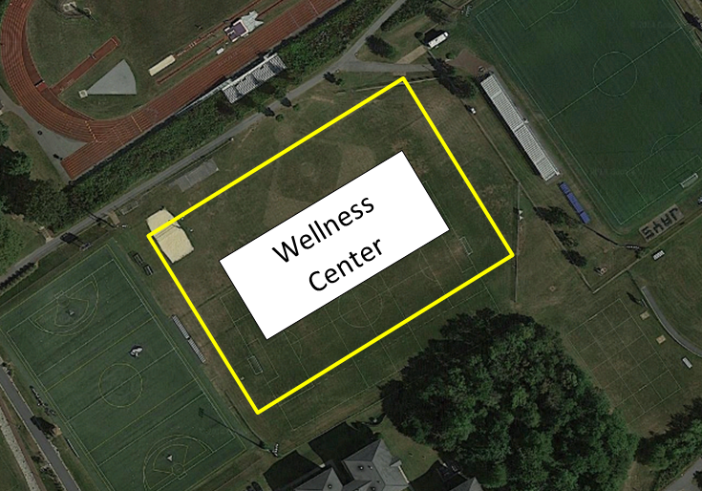
The acoustics of the building are also an important concept that must be designed properly. The school may choose to use the wellness center to hose sporting events. If the school decides to do so, then the building should be designed to help prevent noise from being too amplified. If the acoustics in the center are off, then events may seem louder than necessary. Proper acoustic performance also gets the wellness center design an additional point for the LEED accreditation.
Figure 1 – proposed location for wellness center

Additional Points

Although LEED certification is a main goal, there are additional points that were deemed important in the design of the wellness center. These points range from concepts of aesthesis to concepts towards making the wellness center even greener.

These additional points selected for the design of the wellness center are the following:
- Atrium at Entrance
- Seating and Tables for students to work on school work together
- Large Windows for Natural Light
- Industrial Look (like Jay Walk)
- Green House on Roof
- 200m Regulation Track
- Faculty and Staff get bottom floor in parking garage

An atrium for the entrance of the wellness center is intended to allow an open floor plan. There will be plenty of large windows allowing for natural lighting of the entranceway. A design such as this allows for saving energy by using natural sunlight, rather than artificial lights. The look of the wellness center will have more of an industrial look. This appearance is similar to the Jay Walk, with industrial style exposed ductwork and beams with high ceilings and metallic finishes.

Available tables and seating around the wellness center are also very important. Plenty of tables will allow students to sit down and work together on projects. Spectators could also use the extra seating during sporting events if necessary. Something as small as a table could increases the amount of students willing to come and use the wellness center.

Another idea for the wellness center would be to have a green house located on the roof of the building. The green house could be used to grow vegetation to possibly feed students, or it could be used to hold classes. Students could use the green house to study different plants and the life cycle of plant life.

Another very important feature of the wellness center will be the two hundred meter regulation track. Having this track will allow the school to hold indoor sporting events. This could, in turn, earn the school extra money by holding these events. Other doors will open up too by having an indoor regulation track.

Location Discussion

The wellness center will be located between the turf field and soccer game field. This way it is not too far away from the center of campus and does not clutter everything. A parking garage will be located across the street from Brinser to provide more parking for staff, students, and visitors of Elizabethtown College.

The location of the wellness center is very important in the design process for this building. The center must be in a location that will promote the most usage from the largest group of students, and maybe even the community. For this reason, between the turf field and soccer field is a perfect location.

This location is near the center of campus, so that the wellness center will be easily accessible to large populace of the students. Another benefit to choosing this location is that the land has already been cleared. This means that no additional trees will need to be cut down in order to construct the wellness center. The land is also very flat, making it easier to construct on it. Using the land that is already developed like this will also cost less money. It will take less money to develop the land since it already has a sports field over the selected area.

Another design feature that was thought of was to create a parking garage. The parking garage would help to alleviate the problems that students and faculty have when parking across campus. Right now, most employees park in the parking lot next to Brinser; however, if a parking garage is constructed in an optimal location then the parking lot may be able to become a student lot for students living in the Brinser dorm.
The proposed location for a possible parking garage is for it to be built across the street from Brinser, in the open field near the garden area on Cedar Street. This location is not much further away from the current location of parking for staff members, so this new parking garage will not cost them much inconvenience since it is still close.

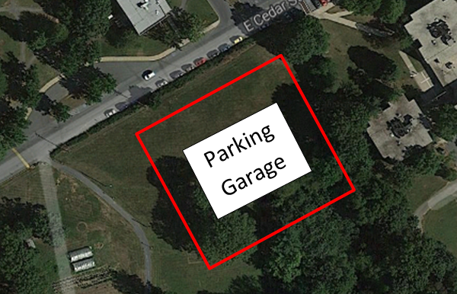
Figure 2 - Proposed location for parking garage for the wellness center

The idea of having staff parking on the first floor of the parking garage is another idea for the garage. Staff members will be regularly coming and going from the parking garage, and for this reason should be given the easiest of access in it. First floor parking access for staff members will also encourage the staff to use the parking garage, leaving even more spaces for students.

Another benefit to this location and parking garage is that any additional floors will be available for students. The second floor could be reserved for commuting students since they, like the faculty members, will be driving to and from the college on a daily basis. Using the parking garage this way will also open up more parking across campus, removing commuter parking from the various other parking lots around campus.

Building Design

It was decided that three floors, a basement, ground floor, and second floor, is the best layout for the wellness center. Different ideas for the layout of the floors were debated, and eventually a final design was agreed upon.

The basement will be home to eight locker rooms to be used by men and woman’s soccer and field hockey teams during the fall. The cross-country team will stay in Thompson Gymnasium. Indoor track teams will use the locker rooms in winter as well as in the spring. Both men and women’s basketball teams, swimming, and wrestling team will remain in Thompson Gymnasium as well. In the spring baseball, softball, and men and women’s lacrosse teams will use the locker rooms. There will also be one coach/official locker room to be used by the coaches of the teams. Both men and women’s tennis teams will stay in Thompson as well.

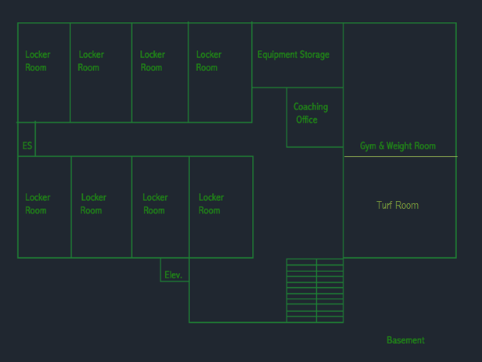
Figure 3 – proposed floor plan for the basement of the wellness center

A large storage room with a lot of shelves will be in the basement to store athletic equipment. A turf room is located here for the off seasons of soccer, lacrosse, softball, baseball, and field hockey team usage. This is a better surface for them to practice on than a hardwood floor. A larger weight room will be located here since the Body shop is very small and fills up rather quickly.

A proposed floor plan was designed, and then a three-dimensional rendering was modeled for the project. The rendering is done to give a view of how the floor would appear when constructed. It is very useful for designing appropriate sized gym and weight rooms, locker rooms, and offices.
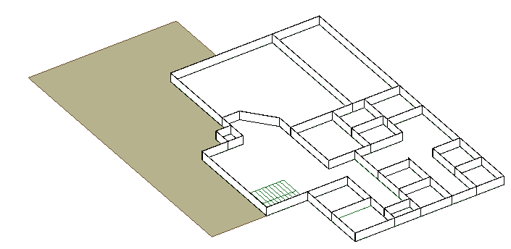
Figure 4 - Three-dimensional rendering of proposed basement level for wellness center
Upon entering the wellness center, there will be a patio for people to do school work or enjoy a meal. Students will be able to do school work in natural sunlight, in a relaxing environment. There will also be a fountain on the patio, providing relaxing water sounds.

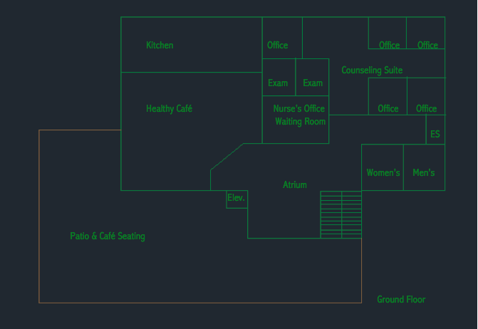
Figure 5 - proposed floor plan for the ground floor of the wellness center

To the right will be another cafeteria, take-out-style, where meal swipes can be used in an all you can eat style snack station. The kitchen will be located behind it. There will be additional seating inside to eat, to reduce the crowds in the Marketplace at peak times. This cafeteria is located on the ground floor so that people can go in and out quickly if they are in a rush.

Counseling would be moved over to this new wellness center. It is located in the back corner so students that are seen going here will not feel like they are being watched. A nurse’s office will be located here so students do not need to travel down to the Hershey Medical Center to receive attention.

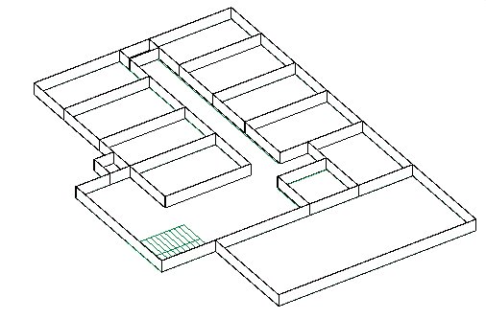
Figure 6- Three-dimensional rendering of proposed second floor for wellness center

The regulation size indoor track for the track and field team will be located on the second floor. Other Elizabethtown College student, faculty, or staff can also use the track. It is a great alternative to running on a treadmill, which always fill up quickly, especially in the winter months.

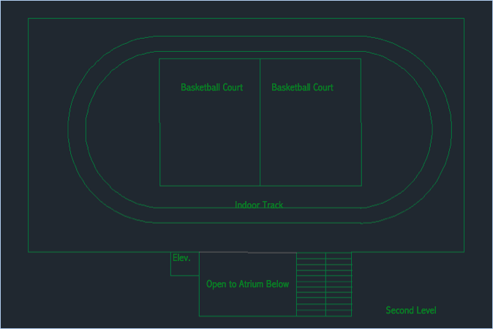
Figure 7 - proposed floor plan for the second floor of the wellness center

There will also be room for bleachers for spectators to watch the various events. Inside of the track will be two basketball courts that can only be used for intramural sports or off-season training. There will be partitions that can be lowered between and around the track.

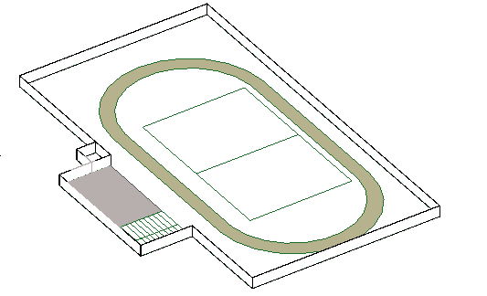
Figure 8- Three-dimensional rendering of proposed second story for wellness center
On one wall there will be a rock wall. Suspended above the track will be a high ropes course. This will be great for on campus activities and sports team bonding. Small storage rooms will be located on this floor for convenience.

Goals

Goals that also need consideration when designing the wellness center include the following: proper integration of mind, body, and spirit; actively promote unity of students, faculty, and staff; actively promote unity of athletics, academics, and student services; sustainability of the building; promote wellness across all cultures and beliefs; and consider allowing the outside community to use the facilities.

A big goal is properly integrate mind, body, and spirit into the design of the wellness center. Meaning that students should be able to come here for spiritual healing. The patio is good for promoting this goal because it is a large and open space that could be used by clubs like “Cru” on campus to hold meetings, and talk together with the other members of the club.

The layout of the wellness center is to encourage the use of the facility and to bring students and staff together in the same place. With the open layout students and staff can use the wellness center as they please. Professors may use the tables to grade, while students use the tables to work on homework and projects. The goal to actively promote unity of students, faculty, and staff will be a great outcome from the wellness center.

Promoting unity of athletics, academics, and student services is another goal that is met through this design. Counseling Services is easily available, and so are coaches and athletic equipment. At most points in the day a student will be able to come and exercise, or may come and study. Coaches can help their team members when they are in the wellness center, with athletic practices or with academics if the coach is able. By promoting the groups to be near each other, unity amongst athletics, academics, and student services is a probable outcome.

As previously discussed, the building is being made in hopes to receive a LEED certification. Part of this goal over laps with the goal for sustainability of the building. In order for the building to be LEED certified, the building must make an emissions plan and be sustainable while not being detrimental to the environment. For the various reasons selected in the LEED section, the wellness center will be sustainable and last a long time in standing and usage by the students.

The final goal, to promote wellness across all cultures and beliefs, is another goal that has been considered. Wellness can be promoted to all cultures and belief by creating team sports, like intramurals, and having the various teams compete against each other for fun. Also, decorating the wellness center to promote multi-cultural interactions is another idea for the center.

It is uncertain whether students would like to allow the outside community in to use the facilities. Some students may be deterred from going if they know that anyone could use the facility. Another argument is that there is a fitness center open just down the street from the college. That is another option for the community to use.

Conclusion
In conclusion, a design for a LEED certifiable wellness center is possible to design. There are many ideas and concepts that must be considered when designing this wellness center. The impact of the construction, the impact of the building, the impact on students, there are many things to consider.

The proposed design will help accomplished the aforementioned goals, and also receive a large amount of points for LEED accreditation. The facility will help bring new life to the campus, and bring some much-needed change.

References

http://eosclimate.com/refrigerant-asset-system-2/refrigerant-management/

